## **Part 1: Show and Tell**

### Screenshots [Confidential] GreyCampus LMS with accounts module

*Student view*

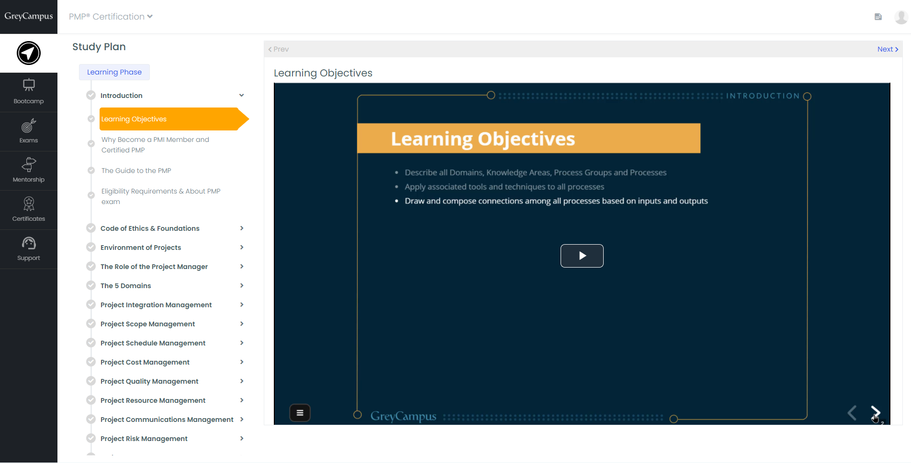

*Student App Prototype****:*** <https://www.figma.com/proto/n3rdQsVFbrSrCRFUSWaFyB/Mobile-App?node-id=8%3A16&scaling=scale-down&page-id=0%3A1&starting-point-node-id=1%3A2>

*Operations*

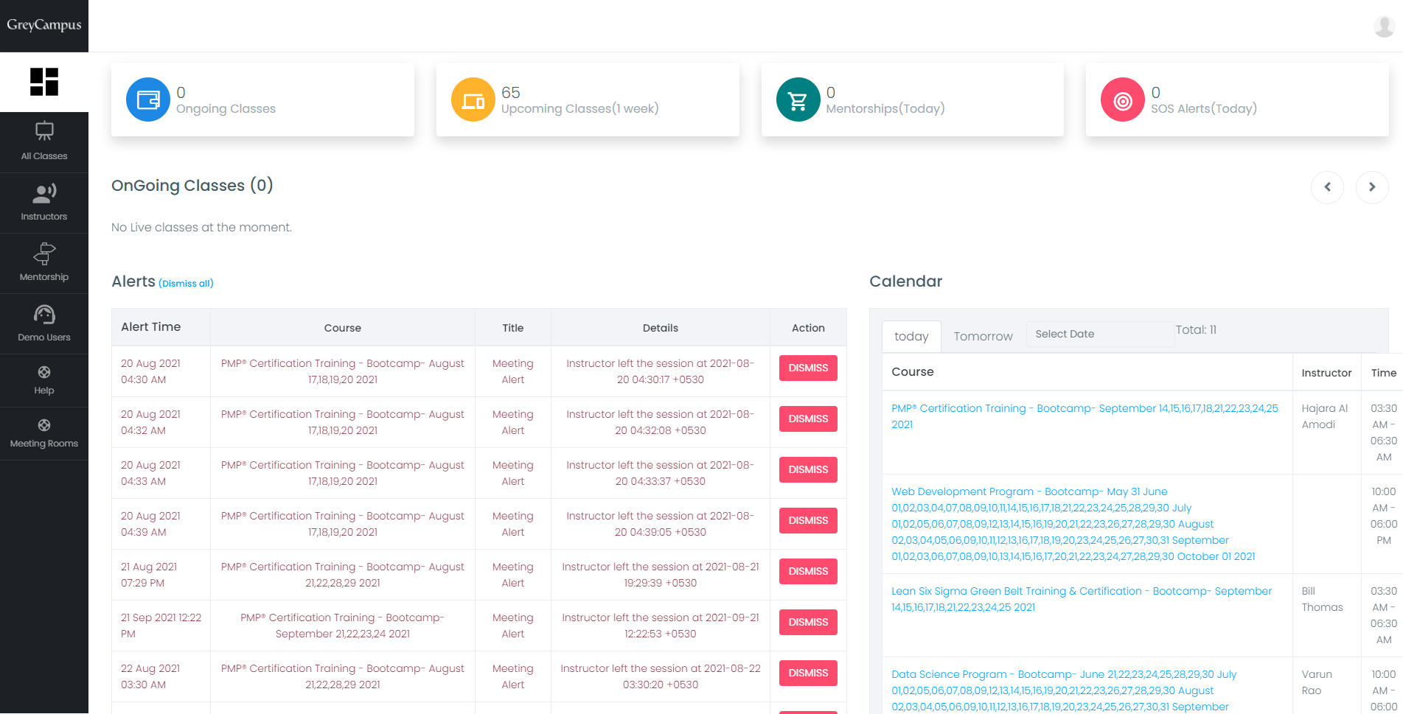

*Accounting*

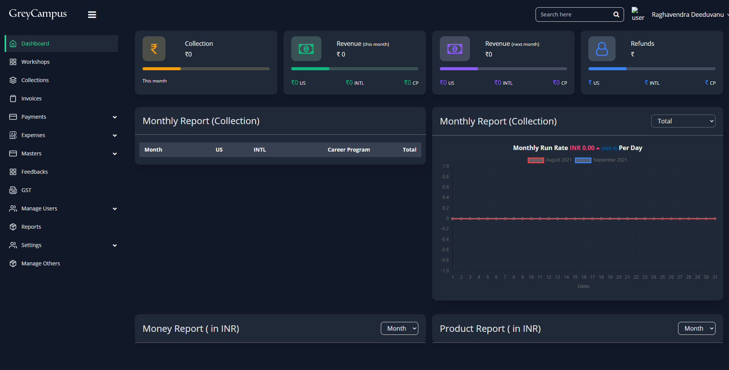

### Response

1. **Why was it developed?**  
   GreyCampus had an LMS(v19) that needed an upgrade to
   1. have better visibility to student’s and transactional level data to the internal teams.
   2. improve UI/UX for students and trainers
   3. reduce the number of clicks for all the users
2. **Who was it for?**The actors are
   1. Students
   2. Trainers
   3. internal teams: operations, marketing, content admin, trainers, business owners
3. **What was it like before?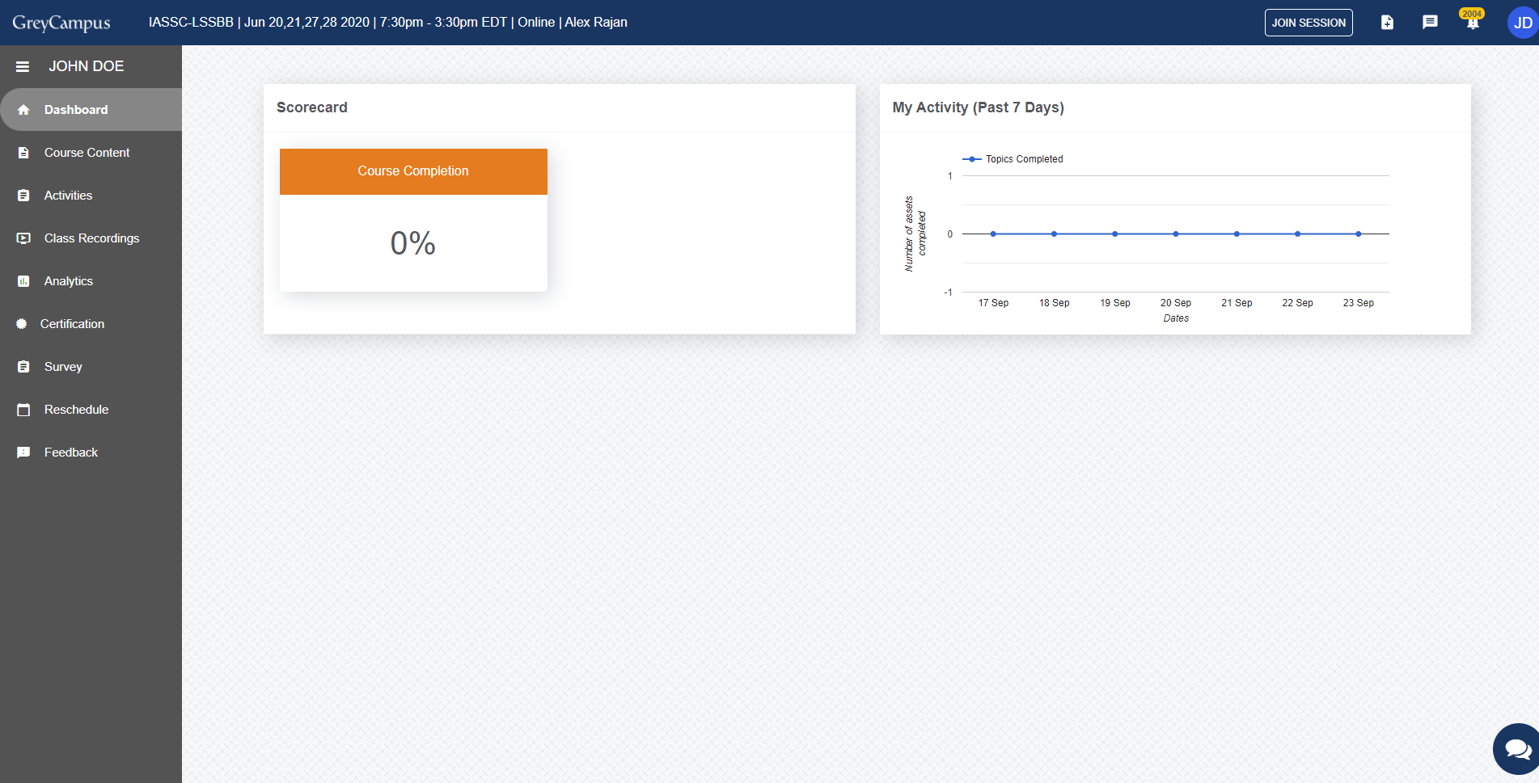**Screenshot of GreyCampus v19’s student viewIt was a system that solved the purpose for 40k learners but could be scaled in terms of features. The process back then required back and forth communication between the operations, product and dev teams increasing turnaround time and affecting the work culture.
4. **What did you change?**

I ensured that

* 1. group the features into components for better feature management
  2. all the actors had relevant information on their portals to act with fewer clicks
  3. An open and transparent process for effective communication between dev, content and operations teams
  4. The operations team had a borrowed student view to handle any queries

1. **Why did you make those changes?**I made the changes to increase the value of the LMS to the organization and to students. Create a platform that could host any number of courses.
2. **What was the response/adoption?**When the number of users reached 100k in Jan’21, users did not face any ambiguity using the LMS. Organizationally, the existing workforce was able to manage the operations without any hassle and need for new resources. Effective UX cut down time on user education and ensured smoother transition.

## Part 2: Scenario

Note: Product and Platform are used interchangeably

1. What assumptions are you making about this project?  
   Assumptions for the project:
   1. There is a market for the product and there is no competition
   2. The audience are accustomed to make payments online
   3. Internet connectivity is good in the place where the product is to be implemented
   4. Cost of hardware and Internet are reasonably priced in the market where the product is going to be launched
   5. Users of the product have a basic understanding of how to interact with the hardware
   6. The budget for the product is limited
   7. The team size is small, for developing and delivering the product
   8. The product is built for scale and across geographies
2. What are the goals for each of the stakeholders for this project?

Proposed solution: developing a cloud-based system to

* digitize the enrollment of fundraisers and donors
* track the financial information  
    
  Stakeholders and their goals:
* Non-profits: recruit fundraisers to the events (Fundraisers Management)
* Fundraisers: set a walking goal and track the donations received (Goal Management and Accounting)
* Donors: donate to the fundraising events (Transaction Management)
* Granicus Dev: ensure that the system works glitch-free and with zero downtime, scalable across the globe
* Granicus Marketing: make selling superfluous, create a digital presence for the product which also includes user education videos of how to use the proposed system
* Granicus Design: ensure that user education is kept to least by elegant UI/UX

1. What will the product do? What will explicitly not do, that people might incorrectly assume it is doing?  
     
   The product will do the following:
   1. Non-Profits Management
      1. Sign up Non-profits so that they can use the platform
      2. Dashboarding: so that the stakeholder understand the event and success of it
   2. Fundraiser Management:
      1. ensure that the stakeholders are enrolled on the platform
      2. fundraisers users are educated on how to use the system
   3. User Management
      1. Create various users at Non-profit, fundraiser levels
      2. Modify the details of the users
   4. Transaction Management (Financial)
      1. Ensures that the transactions are source mapped
      2. state management of financial transactions
      3. Includes logging of the events
      4. Integration with payment gateways
   5. Reporting and Dashboarding

The product will not:

* Track the distance covered during walks
* Verify fundraisers
* Saves card details

1. What does success look like? What are the key metrics that you expect this product to improve? How will we know if this product is successful?  
   Metrics that will define the success of this product:
   1. No. of users and active users at various levels: Non-Profit, Fundraisers, Donors
   2. Money transacted using the platform
   3. Goals reached by the fundraisers to help Non Profit
   4. Downtime and number of glitches: the lower the better
   5. Geographical usage of the product
   6. Speed of execution within the platform

I will keep a track of the metrics and if the metrics like (d) is low whereas the other metrics mention above improve month on month, I would term the effort successful. This is with an assumption that there is no cost overrun.

1. Identify an area(epic) of this project to focus on  
   **Epic**: Transaction Management
2. Write <=5 stores that demonstrate how you would break this epic into stories. Your level of detail is more important than scope.

User Stories:

* 1. As a Non profit organization, I would like to enroll a fundraiser, So that I can receive donations
  2. As a Fundraiser I would like to Create a payment/transaction record, So that I can better manage my donations
  3. As a Fundraiser I would like to send payment link to the donor, So that they can make the donation online
  4. As a donor, I would like to get donation receipt, So that I can confirm that my donation got registered
  5. As a Fundraiser, I would like to understand status of the payment, So that I can reconcile my payments

1. Choose two stories from above and write requirements/acceptance criteria that could be achievable in a 2 week-sprint

#### User Story 1: As a Fundraiser I would like to Create a payment/transaction record, So that I can better manage my donations

Acceptance Criteria:

Scenario: A fundraiser user records the payment received from a donor   
  
Dependencies: Email service, Reporting, User and role management

Given I received a donation in cash by a donor

When I click on ‘Add Donation’ button

Then I should see the form to fill in the details

When I add the details (Name| Email | Currency | Amount) and click on save

Then I should see a alert to confirm the money received and

When I click on Proceed

Then I must see a success message in green and the form has to be refreshed to add another record AND donor must receive an email of the receipt

When I do not add all the necessar fields and click on save

Then an error message against the field needs to be shown with a description of what went wrong

#### User Story 2: As a donor, I would like to get donation receipt, So that I can confirm that my donation got registered

Acceptance Criteria:

Scenario: A donor makes a payment for an walkathon event by cash

Given I made a donation to a fundraiser

When the amount is collected and fed into the system

Then I should get a receipt as a confirmation by email for the donation which includes payment details